**GRIET SKILL DEVELOPMENT CELL (SB)**

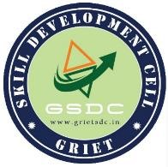

29th August 2022

Hyderabad

To

Head of Department, IT

GRIET,

HYDERABAD

**Sub: Request to allot a room to conduct recruitment interviews for SDC-SB .**

Respected Sir,

We, team SDC-SB GRIET, want to conduct recruitment interviews for the 1st and 3rd years. We kindly request you to grant us access to any vacant room in **BLOCK 3 on Tuesday 30th August** **from 9:30 AM to 4:30 PM** as we need to recruit them into SDC-SB. Kindly oblige our request.

Thanking you

Yours Faithfully

J. Charan Teja Reddy

(President SDC SB)

__________________ __________________

Dr. G. S. Bapi Raju Dr. N V Ganapathi Raju

(Chief Instructor SDC) (HOD IT)